FinTech Innovation Proposal

Explainable and Ethical AI Credit Scoring for Digital Lending Ecosystems: Integrating Traditional, Modern, and BNPL Data

1. Background
The rapid growth of Buy Now, Pay Later (BNPL) and digital lending has expanded access to credit, especially among younger and underbanked consumers. However, traditional credit scoring systems that rely solely on bureau data such as income, age, and loan history often fail to capture the full picture of financial behavior.
Meanwhile, digital finance generates rich behavioral data from mobile payments, BNPL activity, and e-commerce transactions that can reveal repayment discipline and financial stability. Yet, few models have effectively integrated traditional, modern, and BNPL data into one explainable and ethical AI framework.
This project aims to build a hybrid AI credit scoring system that merges these data types to create a transparent, fair, and inclusive model. The focus is on Southeast Asian BNPL ecosystems but the framework is scalable to global digital lending contexts.

2. Objectives
1. Develop a unified AI credit scoring model combining traditional, digital, and BNPL data sources.
2. Enhance model transparency through Explainable AI (XAI) methods such as SHAP and LIME.
3. Promote financial inclusion by assessing creditworthiness for digital-first, underbanked users.
4. Create a universal lending framework adaptable to BNPL, micro-loans, and bank products.
5. Deliver a working dashboard prototype to visualize credit scores, feature importance, and bias metrics.

3. Data and Variables
Category | Key Variables | Source
Traditional Credit Data | AMT_INCOME_TOTAL, AMT_CREDIT, AMT_ANNUITY, DAYS_EMPLOYED, EXT_SOURCE_1–3, CODE_GENDER, NAME_EDUCATION_TYPE, REGION_RATING_CLIENT | Home Credit (Kaggle)
BNPL Transaction Data | bnpl_payment_freq, bnpl_on_time_ratio, bnpl_avg_purchase, bnpl_overdue_count | Simulated / proprietary BNPL data
Digital Behavior Data | mobile_txn_freq, wallet_balance_volatility, bill_payment_timeliness, avg_order_value, online_payment_ratio, fraud_flag | PaySim, Open Bank Project API, Global Findex
Target Variable | TARGET = 1 (defaulted), 0 (non-default) | Home Credit / labeled dataset

4. Methodology
The methodology involves building a hybrid data-driven pipeline integrating traditional, digital, and BNPL data to predict default risk with transparency and fairness.
Stage | Description | Tools
Data Integration | Merge and normalize datasets from multiple sources into a unified schema. | Pandas, SQL, NumPy
Feature Engineering | Create new features such as payment ratio, utilization, and wallet volatility. | Python
Model Development | Train ML models (Logistic Regression, Random Forest, XGBoost) and compare accuracy. | scikit-learn, XGBoost
Explainability Layer | Interpret model outputs using SHAP and LIME for transparency. | SHAP, LIME
Fairness & Bias Auditing | Audit demographic bias using Fairlearn and fairness metrics. | Fairlearn, Aequitas
Dashboard Prototype | Develop a Streamlit dashboard for visualization and what-if analysis. | Streamlit, Plotly

5. Conceptual Framework
The framework integrates traditional and digital credit data into an AI model pipeline: Data Integration → Feature Engineering → AI Modeling → Explainability Layer → Lending Decision Dashboard. This ensures the credit scoring process remains interpretable, ethical, and adaptable across credit types.
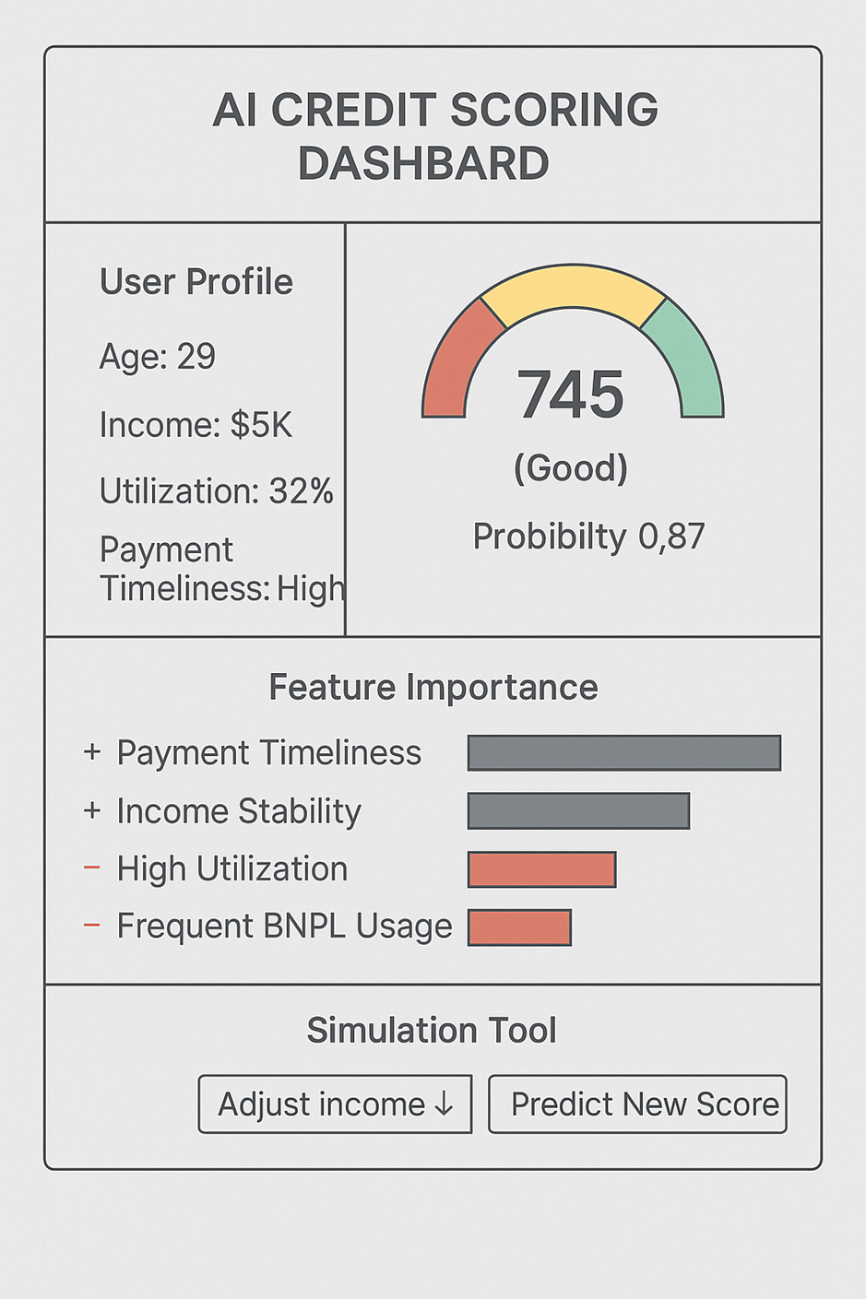
Figure 1. Hybrid AI Credit Scoring Workflow (Author’s Design)

6. Expected Outcomes
- Creation of a hybrid, explainable AI credit scoring model that enhances prediction and fairness.
- Interactive dashboard prototype for transparency and simulation of credit decisions.
- Quantitative fairness and bias reports for ethical lending evaluation.
- Empirical framework applicable to academia, banking, and policy sectors.

7. Ethical and Regulatory Considerations
1. Ensure data usage complies with Privacy Act 1988 (Cth), GDPR, and Open Banking standards.
2. Regular bias audits to identify unfair treatment across gender, age, and income groups.
3. Align with ASIC RG 271 and EU AI Act 2024 for responsible AI lending.
4. Implement SHAP-based explanations to ensure transparency for users and regulators.

8. Significance and Impact
This research bridges inclusion and accountability in FinTech by combining traditional and modern data for credit risk assessment. It demonstrates UNSW’s leadership in responsible AI innovation, offering global scalability for digital-first consumers while maintaining fairness and transparency in financial systems.

9. Applications, Deployment, and Broader Impact
The AI Credit Scoring Dashboard can be deployed across multiple environments:
- Digital Lending & BNPL Firms: Real-time risk scoring and credit decision dashboards (e.g., Atome, Kredivo, Klarna).
- Digital Banks & Neobanks:** Transparent AI scoring during loan onboarding (e.g., Revolut, Jago, SeaBank).
- Financial Inclusion Programs:** Assessing unbanked populations using behavioral data (e.g., Kiva, Jumo, Tala).
- Regulators & Policy Labs:** Fairness audit sandbox for responsible AI governance (ASIC, MAS, Bank Indonesia).
- Academic & Research Institutions:** Research demonstrator at UNSW FinTech Lab and CSIRO Data61.
- Corporate Embedded Finance:** Credit scoring integrated into insurance, telco, and e-commerce systems.

10. Future Enhancements
1. Expand the model to multiple lending products (credit cards, auto loans, microfinance).
2. Enable real-time open banking data updates for dynamic credit scoring.
3. Add automatic bias monitoring dashboards with alert systems.
4. Develop a user simulation tool for understanding credit behavior impact.
5. Collaborate with regulators and industry partners for pilot deployment.

11. Data Sources and References
- Home Credit Default Risk Dataset (Kaggle)– https://www.kaggle.com/competitions/home-credit-default-risk/data
Traditional loan data used to model default risk.
- PaySim Mobile Money Dataset – https://www.kaggle.com/datasets/ealaxi/paysim1
Simulated mobile transaction dataset reflecting modern behavioral finance.
- Online Retail II Dataset (UCI) – https://archive.ics.uci.edu/ml/datasets/online+retail+ii
E-commerce transactions used to simulate BNPL payment behavior.
- Global Findex Database (World Bank) – https://datacatalog.worldbank.org/search/dataset/0037712
Global digital financial inclusion dataset for cross-country insights.
- Open Bank Project API Sandbox** – https://sandbox.openbankproject.com/
Synthetic open banking data source used for testing account and payment integrations.
- Supporting Literature:
- FICO (2024). *BNPL Data Integration in Credit Scores* (Investopedia).
- Synapse Analytics (2024). *Alternative Data for BNPL Credit Decisions.*
- OECD (2023). *Responsible Lending in Digital Finance.*
- UNSW FinTech Research Hub (2025). *Ethical AI for Financial Inclusion.*

12. Conclusion
This project proposes an explainable, ethical AI credit scoring framework that merges traditional, BNPL, and digital behavioral data into a transparent, fair, and globally adaptable lending solution. It aims to make credit systems smarter, more inclusive, and aligned with UNSW’s Responsible Innovation values.

